**Activity: Editing files in Linux(have to do)**

1. Issue: some prices are missing or incorrect in the file: stock_sample.csv.

Commands used : grep

* Identify the products with an incorrect price:

**Before:New York Stock Exchange Arca,AMEX,VanEck Gold Miners ETF,xx.xx,GDX,et**

**New York Stock Exchange,NYSE,General Electric Company,A4.35,GE,stock**

**After:New York Stock Exchange Arca,AMEX,VanEck Gold Miners ETF,23.05,GDX,etf**

**New York Stock Exchange,NYSE,General Electric Company,64.35,GE,stock**

1. The client would like additional information to be included in the stock_sample.csv file:

* Find the product information from stock2022_09_28.csv for TSLA, MSFT, MS:

**grep -E '^([^,]*,){4}(TSLA|MSFT|MS),' stock2022_09_28.csv**

NASDAQ Global Select,NASDAQ,MicrosoftCorporation,236.66,MSFT,stock

New York Stock Exchange,NYSE,Morgan Stanley,80.7,MS,stock

* The client asks that the new data be added starting line 4. Anything from lines 4 to 10 should be moved down.
* To ensure you're on target, display the line numbers in your vi tab.

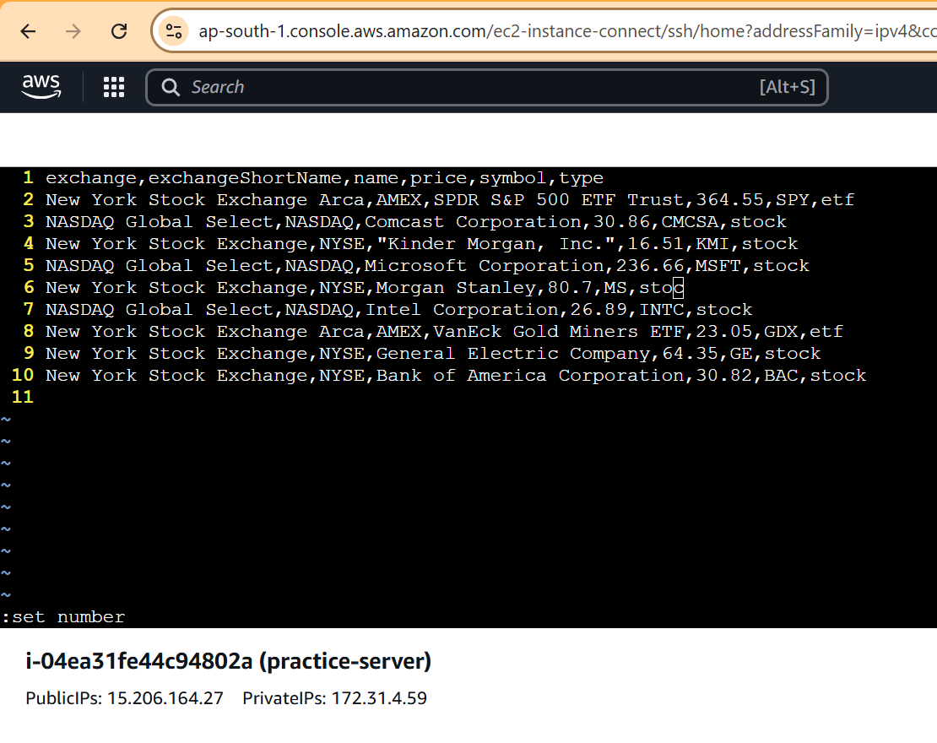

1. Big news: The New York Stock Exchange has just been bought by Wiley and is now the Wiley US Stock Exchange. The client is requesting our help to change some information in bulk, as we displayed some skills using vi.

Use the search tool in vi to search for “New York Stock Exchange.”

Use the substitute (s) command within vi to search and replace the occurrences of “New York Stock Exchange” with "Wiley US Stock Exchange."

Save and quit your file.:  
vi stock_sample.csv

/New York Stock Exchange

:%s/New York Stock Exchange/Wiley US Stock Exchange/g

